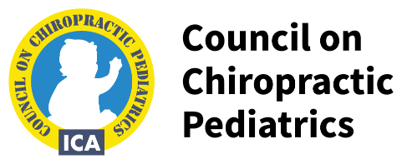

DIPLOMATE IN CLINICAL
CHIROPRACTIC PEDIATRICS
APPLICATION FOR RENEWAL OF STATUS
Deadline for Renewal is June 15, 2024
I, , hereby apply for renewal of my DICCP status, on today’s date,
. I have fulfilled the following mandatory requirements during the renewal period of January 1, 2020 to December 31, 2023.

- MANDATORY: 1. Continuous ICA Pediatrics Council membership
  - Attended at least one ICA Pediatric Council Annual Conference between 2020-2023
q Orlando (2021) (in-person or live streaming) q Dallas (2022) (in-person or live streaming) q Atlanta (2023) (in-person or live streaming)
  - Completed 24 hours of CE credits in pediatrics at the following conference/seminars:
hours at Pediatric Councils Annual Conference in
No need to attach certificate from Palmer College or Life West received for Annual Pediatrics Conferences
hours at seminar co-sponsored by ________________________________________________ held
____________________________________________________________________ (provide date & location)
Please attach CE certificate for programs not sponsored by the ICA Pediatrics Council
- ADDITIONAL: I also qualify for one of the following to receive a $50 discount (check only one)
The following should be between Jan 2020-Dec 2023
q Current member of ICA with membership active and current for at least one year
q Teach chiropractic pediatric and/or prenatal care at any accredited chiropractic college or the ICA pediatric diplomate program.
q International DICCP
q Published or presented a paper on chiropractic pediatrics and/or pregnancy in a peer-reviewed journal in the past 3 calendar years. (Please include link or title of paper)

FEE for Renewal $150
One discounted option ($50) $ TOTAL DUE: $_____________
I am paying by check (Please make payable to International Chiropractors Association)
q Master Card q Visa q American Express q Discover
Account # Exp Date CVV Code: Your Signature Email:
DICCP’s who do not meet the mandatory requirements will be suspended until such time as the requirements are met. Suspended DICCP’s may apply for reinstatement after fulfilling requirements. Reinstatement fee is $100.00

Please mail form with payment to:
International Chiropractors Association, Attention Council on Pediatrics, 6400 Arlington Blvd, Suite 650, Falls Church, VA 22042

Payment by credit card may be:
Faxed to 703-528-5023 ( secure fax) or Email to accounting@chiropractic.org

